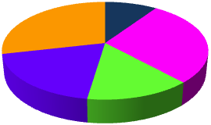

**Mined Systems Inc.**

**Metrics Intelligence ©**

# 

**SOW 3B, v2 Design Document, Release 12.9**

**September 26, 2012**

Table of Contents

1 Gap Analysis Functionality 3

1.1 Gap Analysis Data “Selection” 3

1.2 Gap Analysis “Data Elements” 4

1.3 Gap Analysis Data “Report” 5

1.3.1 As-Is Information 5

1.3.2 Desired Annual Improvement % 5

1.3.3 Gap Analysis Report “Graph” 6

1.3.4 To-Be Information 6

1.3.5 Gap Analysis “Navigation” 6

1.4 Gap Analysis Function Performance by User Role 7

2 Return on Investment (ROI) Functionality 8

2.1 ROI Data Input 8

2.1.1 Edit: Gap Analysis Record 9

2.1.2 View: ROI Report 9

2.2 ROI Report 10

2.2.1 Training Expense Information 10

2.2.2 ROI Bar Graph 10

2.2.3 ROI Report “Navigation” 10

2.3 ROI Function Performance by User Role 11

3 Gap Analysis Data Selection and ROI Calculations 12

3.1 Gap Analysis Data Selection 12

3.2 ROI Calculations 12

**Table of Figures**

Figure 1‑1: Gap Analysis Data Entry Screen 3

Figure 1‑2: Gap Analysis Data Selection Table Recommendations 4

Figure 1‑3: Gap Analysis Report Screen 5

Figure 2‑1: Return on Investment Data Entry Screen 8

Figure 2‑2: Return on Investment Report Screen 10

Figure 3‑1: ROI “Gap” for the 6 Elements 13

Figure 3‑2: ROI “Annual Improvement Desired” for the 6 Elements 13

Figure 3‑3: ROI Expenditure Amounts 14

Figure 3‑4: Adjustment Factor Tables 14

Figure 3‑5: ROI Calculation Elements 15

**Requirements**

# Gap Analysis Functionality

The gap analysis functionality should provide the Sandler Metrics System (SMS) user with the capability to identify where a prospective company’s “As-Is” capabilities are within 6 specific measurements and how those measurements compare to their desired “To-Be” capabilities. This functionality will be processed in a few simple steps using the Gap Analysis functionality within the SMS.

## Gap Analysis Data “Selection”

When the user selects the “Gap Analysis” button on the top line menu, they will come to the following screen to allow them to select the data ranges for the 6 measurements included.

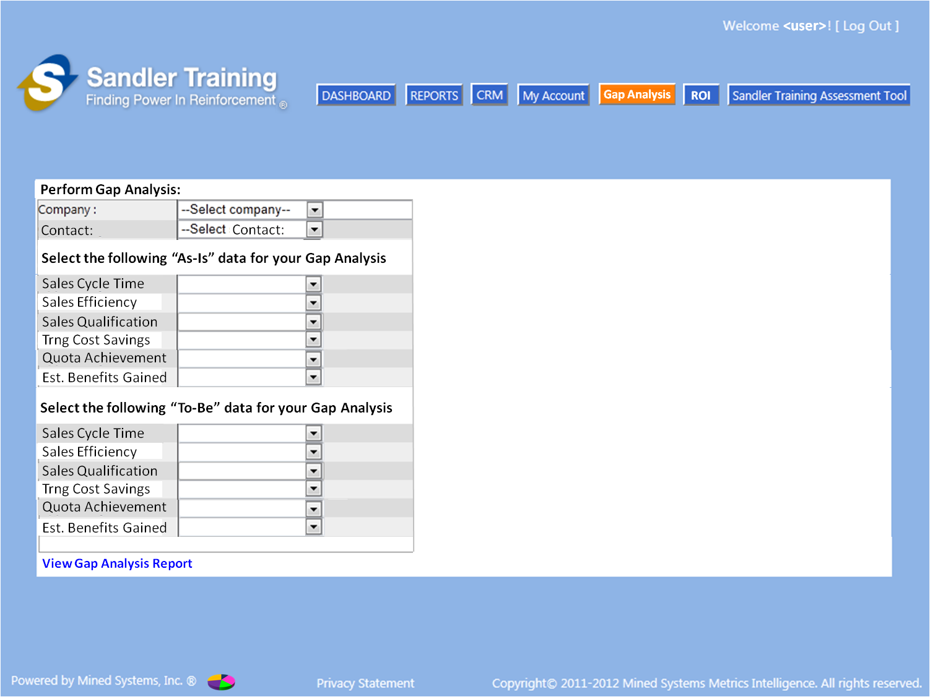

Figure ‑: Gap Analysis Data Entry Screen

* The user will need to first select a Company and then select a Contact that is associated with that Company.
* The user will then make the selections of the “As-Is” elements and the “To-Be” elements (the data for these elements can be found in Section 1.2 of this document).
* Once all of the values have been selected for “As-Is” and for “To-Be”, the user will select “View Gap Analysis Report”

## Gap Analysis “Data Elements”

The information within the data ranges will come from database tables [the orange and gray column within the “bold” box would be considered a table – 6 tables in all] as indicated in the figure below. For right now, the data in the tables represent the expectation and best industry practices. However, in the future, the data in these tables will be populated from data retrieved from calculations performed within the MSI Data Warehouse.

Note: The values in the drop down selection boxes in the “Perform Gap Analysis” screen should come from the values in the orange shaded columns below. The corresponding values in the gray shaded columns (within the “bolded” box) are the values that should be used to populate the chart seen in the figure in Section 1.3.

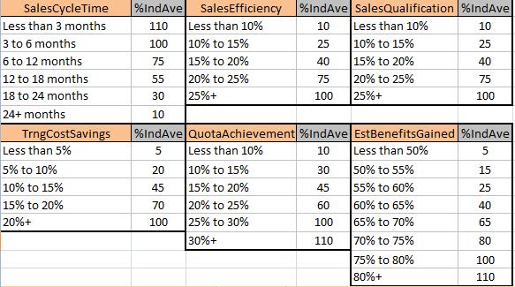

Figure ‑: Gap Analysis Data Selection Table Recommendations

## Gap Analysis Data “Report”

Once the gap analysis report has been selected [from the previous screen] the following screen will appear:

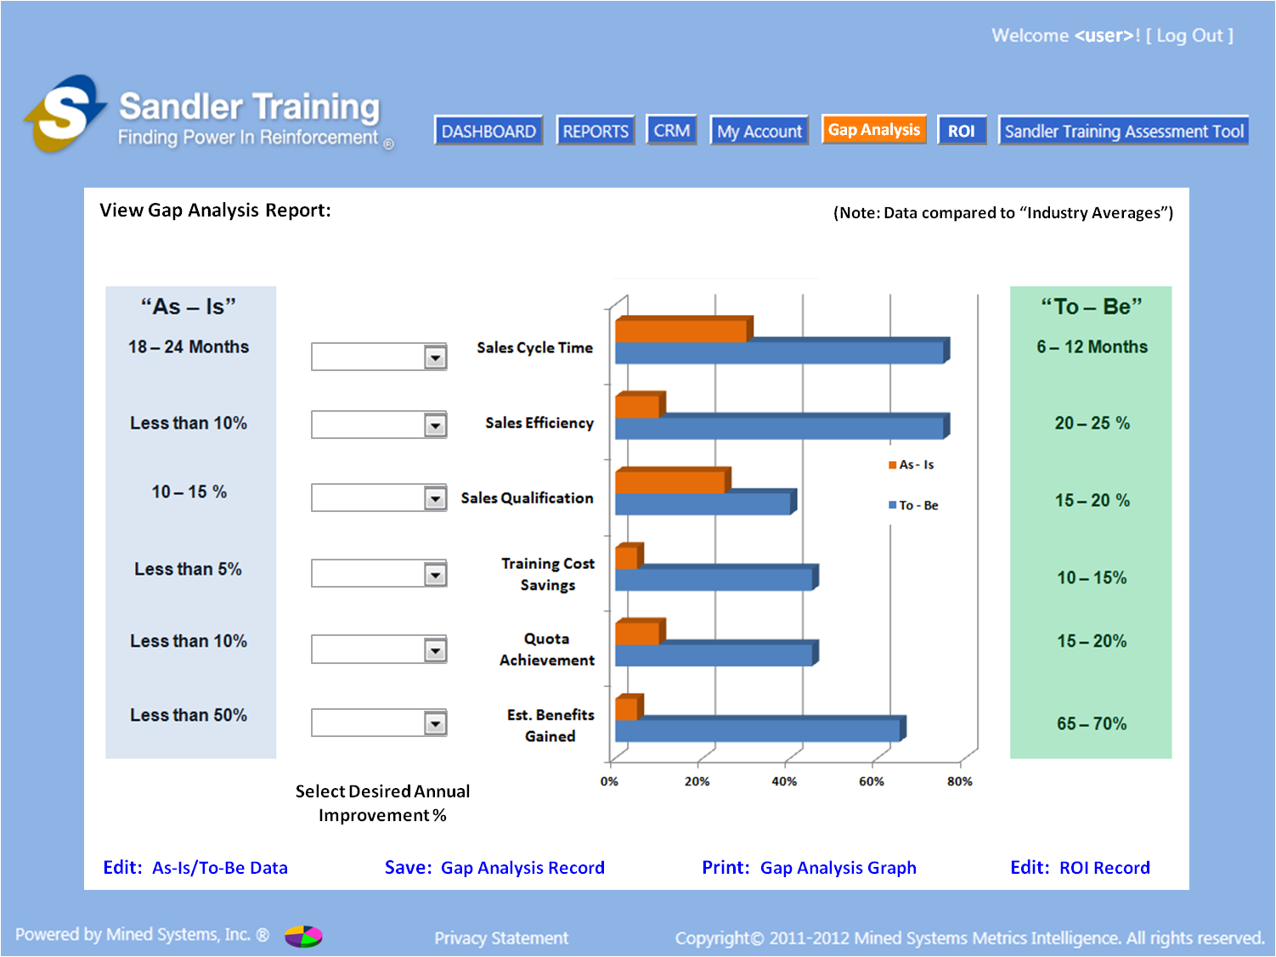

Figure ‑: Gap Analysis Report Screen

(Note: this is an updated diagram)

### As-Is Information

* The values in the “As-Is” column identified are the values from those “orange” shaded columns in Section 1.2 that are applicable to the selections from the “gray” shaded columns in Section 1.2.
* These data fields should be populated from the appropriate fields in the new tables identified in Section 1.2.

### Desired Annual Improvement %

* The “Select Desired Annual Improvement %” fields provide the user with the ability to make a selection of how much they would want to incrementally improve their performance annually.
  + Note: The values in the drop down selection boxes for all 6 of the measurements should be 10% to 100% in 10% increments [e.g. 10%, 20%, 30%....100%]
  + The data captured in this “Select Desired Annual…” field will be used in the ROI functionality.

### Gap Analysis Report “Graph”

* The “graphic” in the middle of the page is based on the data from the “gray” shaded columns in Section 1.2 that are applicable to the “As-Is” or the “To-Be” data that was selected as shown in the “orange” columns in Section 1.2 for all 6 of the measurements.

### To-Be Information

* The values in the “To-Be” column identified are the values from those “orange” shaded columns in Section 1.2 that are applicable to the selections from the “gray” shaded columns in Section 1.2.
* The data fields should be populated from the appropriate fields in the new tables identified in Section 1.2.

### Gap Analysis “Navigation”

* The navigation selections at the bottom of the page are described here:
  + **Edit: As-Is/To-Be Data**
    - This will take the user back to the Figure 1‑1: Gap Analysis Data Entry Screen to allow the user to potentially adjust any of the “As-Is” or the “To-Be” drop down selections
  + **Save: Gap Analysis Record**
    - This will write the record to the database to include the following data for each of the 6 elements: As-Is; Desired Annual Improvement %; Gap % [gap between To-Be and As-Is]; and To-Be
  + **Print: Gap Analysis Graph**
    - This will provide the user with an export/print capability to print out the bar graph so that it can be compared to other “bar graphs” [if they want to keep going back to make changes]
    - It is assumed that the user would need to “save” the record to the database before this “print” function would work - - therefore, the user should be notified to save the record if they try to select this navigation option before saving the record
  + **Edit: ROI Record**
    - This will take the user to the Figure 2‑1: Return on Investment Data Entry Screen and will populate the Company, Contact and “Gap” data from the record being currently viewed
    - It is assumed that the user would need to “save” the record to the database before this “Edit: ROI Record” navigation would be possible - - therefore, the user should be notified to save the record if they try to select this navigation option before saving the record
    - By having this capability, the user will be able to navigate to the ROI functionality [without having to use the “ROI” button in the main navigation] and, more importantly, this will already have the Gap Analysis data populated in the ROI data entry screen for the user

## Gap Analysis Function Performance by User Role

* Franchise User Role
  + ALL Companies in the database for THIS FRANCHISE ONLY will be displayed in the “Select Company” drop down selection
  + ONLY those contacts associated to the selected Company that have been entered by THIS USER will appear in the “Select Contact” drop down screen
  + Can perform the gap analysis and save a gap analysis report for any Contact entered by THIS USER for the Company selected from the “Select Company” drop down screen
* Franchise Owner Role
  + ALL Companies in the database for THIS FRANCHISE ONLY will be displayed in the “Select Company” drop down selection
  + ONLY those contacts associated to the selected Company will appear in the “Select Contact” drop down screen
  + Can perform the gap analysis and save a gap analysis report for any Company selected from the “Select Company” drop down screen
* Coach Role
  + For this release, the Coach Role will not be able to perform the “Gap Analysis” function, therefore the “Gap Analysis” button is disabled [not grayed out, just disabled]
* Corporate Role
  + For this release, the Corporate Role will not be able to perform the “Gap Analysis” function, therefore the “Gap Analysis” button is disabled [not grayed out, just disabled]

# Return on Investment (ROI) Functionality

The return on investment (ROI) functionality should provide the SMS user with the capability to use a previously created [and saved] Gap Analysis to run it through the ROI calculations to determine the amount of the return, and the time frame for the return.

## ROI Data Input

When the user selects the “ROI” button on the top line menu, they will come to the following screen to allow them to select the company and contact [which will populate the Gap Analysis data] and then allow them to enter their estimated Sales Training Expenditures for the next 3 years.

If the user selected the “Edit: ROI Record” from the navigation buttons on the bottom of the Figure 1‑3: Gap Analysis Report Screen, then they would be brought to the figure below with the Company, Contact and “Gap” information already populated with the record they were viewing on the Figure 1‑3: Gap Analysis Report Screen.

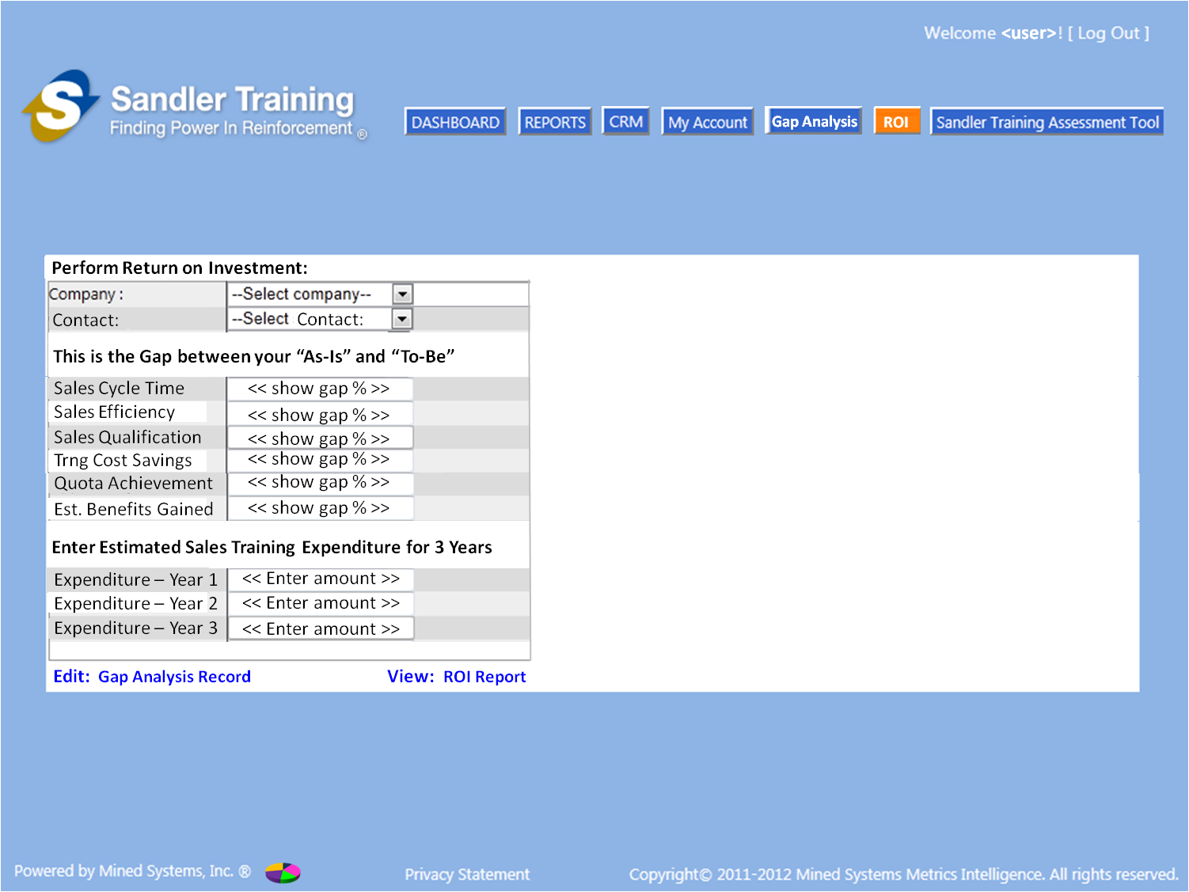

Figure ‑: Return on Investment Data Entry Screen

* The user will need to first select a Company and then select a Contact that is associated with that Company.
* Once the Company and Contact have been selected, the unique record of the “Gap Percentage” for each of the 6 elements for that Company/Contact will be provided
  + When the “gap percentage” data are shown, the fields should be “read-only”
  + If the user wants to change any of those fields, they would need to select the “Edit: Gap Analysis Record” option at the bottom of the screen to return to the Figure 1‑1: Gap Analysis Data Entry Screen to edit the record
* Once the “gap percentage” data have been presented on the screen, the user will then be able to enter the estimated training expenditure dollar amounts for the next 3 years

### Edit: Gap Analysis Record

* This provides the user with the ability to return to the Figure 1‑1: Gap Analysis Data Entry Screen to make any adjustments desired for the “As-Is” or “To-Be” data selections

### View: ROI Report

* This provides the user with the ability to move to the Figure 2‑2: Return on Investment Report Screen where they can see the populated ROI report as well as the planned training expenditures for all 3 years

## ROI Report

Once the user has entered their estimated training expenditures and they select the “View: ROI Report” option at the bottom of the Figure 2‑1: Return on Investment Data Entry Screen, the user will come to the following screen to show them the ROI report as well as the planned training expenditures for all 3 years.

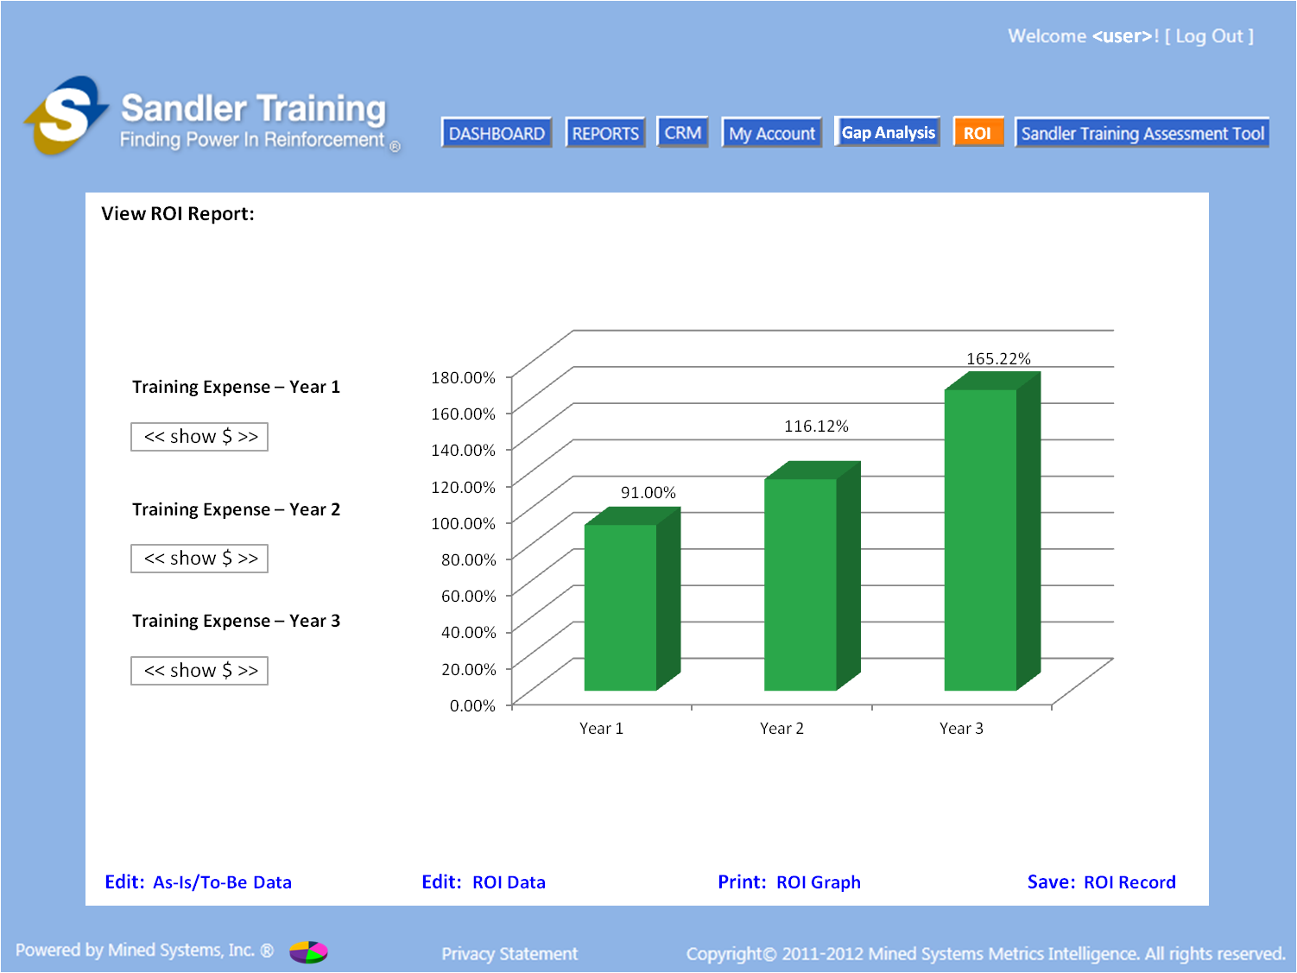

Figure ‑: Return on Investment Report Screen

### Training Expense Information

* The estimated training expense entered in the Figure 2‑1: Return on Investment Data Entry Screen will be shown on the Figure 2‑2: Return on Investment Report Screen as “read-only”

### ROI Bar Graph

* The ROI bar graph will be shown with the ROI values for Year 1, Year 2, and Year 3
* The method of calculation for the ROI values is provided in Section 2.4

### ROI Report “Navigation”

* The navigation selections at the bottom of the page are described here:
  + **Edit: As-Is/To-Be Data**
    - This will take the user back to the Figure 1‑1: Gap Analysis Data Entry Screen to allow the user to potentially adjust any of the “As-Is” or the “To-Be” drop down selections
  + **Edit: ROI Record**
    - This will take the user to the Figure 2‑1: Return on Investment Data Entry Screen and will provide the user with the ability to change any of the “estimated sales training expenditures” for the 3 years
  + **Print: ROI Graph**
    - This will provide the user with an export/print capability to print out the bar graph so that it can be compared to other “bar graphs” [if they want to keep going back to make changes]
    - It is assumed that the user would need to “save” the record to the database before this “print” function would work - - therefore, the user should be notified to save the record if they try to select this navigation option before saving the record
  + **Save: Gap Analysis Record**
    - This will write the record to the database to include the following data for each of the 6 elements: As-Is; Desired Annual Improvement %; Gap % [gap between To-Be and As-Is]; and To-Be

## ROI Function Performance by User Role

* Franchise User Role
  + ALL Companies in the database for THIS FRANCHISE ONLY will be displayed in the “Select Company” drop down selection
  + ONLY those contacts associated to the selected Company that have been entered by THIS USER will appear in the “Select Contact” drop down screen
  + Can perform the ROI update and save ROI report for any Contact entered by THIS USER for the Company selected from the “Select Company” drop down screen
* Franchise Owner Role
  + ALL Companies in the database for THIS FRANCHISE ONLY will be displayed in the “Select Company” drop down selection
  + ONLY those contacts associated to the selected Company will appear in the “Select Contact” drop down screen
  + Can perform the gap analysis and save a gap analysis report for any Company selected from the “Select Company” drop down screen
* Coach Role
  + For this release, the Coach Role will not be able to perform the “Gap Analysis” function, therefore the “Gap Analysis” button is disabled [not grayed out, just disabled]
* Corporate Role
  + For this release, the Corporate Role will not be able to perform the “Gap Analysis” function, therefore the “Gap Analysis” button is disabled [not grayed out, just disabled]

# Gap Analysis Data Selection and ROI Calculations

The calculations and details showing how the numbers are calculated are contained within the excel file embedded here and are explained within the following sub-sections.



## Gap Analysis Data Selection

The Gap Analysis tab of the embedded spreadsheet provides the details of what is shown in Figure 1‑2: Gap Analysis Data Selection Table Recommendations.

* The data selection fields in the for the “As-Is” and the “To-Be” data selections for the 6 elements need to come from tables so that future updates to these data fields can be done simply by updating the reference data within the tables
* Similarly, the “values” associated to the “As-Is” and “To-Be” selections for the 6 elements made in the Figure 1‑1: Gap Analysis Data Entry Screen must also come from tables so that future updates to the data values can be done simply by updating the reference data within the tables
* The “Select Desired Annual Improvement %” fields in the Figure 1‑3: Gap Analysis Report Screen must also come from a table so that future updates to the data values can be done simply by updating the reference data within the tables

## ROI Calculations

The ROI tab of the embedded spreadsheet provides the details of what is shown in the Figure 2‑2: Return on Investment Report Screen. The detailed explanation of how the calculations should be performed is provided in the steps below.

1. For each of the 6 measurement elements [e.g. Sales Cycle Time, Sales Efficiency, etc], when the user selects a value from the drop down list [which is pulled from the associated table], the associated “value” for that selection is pulled from that table and should be written into the associated “As-Is” or the “To-Be” field in the Gap Analysis record.
   1. The example “As-Is” and “To-Be” values are shown in Columns B and C, rows 24 thru 29, on the Gap Analysis tab of the embedded spreadsheet.
   2. These “values” are what will be used to produce the Gap Analysis bar graph shown in the Figure 1‑3: Gap Analysis Report Screen.
2. The difference between the “To-Be” and the “As-Is” values entered in the record as a result of the selections made by the user in the Figure 1‑1: Gap Analysis Data Entry Screen will be the “Gap” that exists for each of the 6 elements. This “gap” is shown in Column C, rows 7 thru 12, on the ROI tab of the embedded spreadsheet.

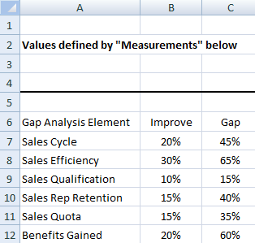

Figure ‑: ROI “Gap” for the 6 Elements

1. The “Desired Annual Improvement %” values entered in the Figure 1‑3: Gap Analysis Report Screen are shown in Column B, rows 7 thru 12, on the ROI tab of the embedded spreadsheet.

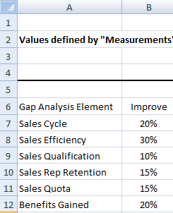

Figure ‑: ROI “Annual Improvement Desired” for the 6 Elements

1. The “Expenditure – Year 1”, “Expenditure – Year 2” and “Expenditure – Year 3” values entered in the Figure 2‑1: Return on Investment Data Entry Screen are shown in columns D, E and F [respectively] on Row 6, on the ROI tab of the embedded spreadsheet.

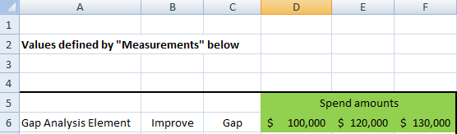

Figure ‑: ROI Expenditure Amounts

1. Two additional database tables are required to conduct the calculations. These are being developed as table values so that future updates to the adjustment factors can be done thru a simple table update that does not require a code change.
   1. TBL_ROI_Adjustment
      1. This table will be used to apply an “adjustment” factor to the calculation of the ROI which is currently based on knowledge and experience with the industry.
      2. As actual data are captured going forward, this adjustment factor may be updated.
   2. TBL_Trng_Expenditure
      1. This table will be used to apply an adjustment “factor” to the calculation of the ROI based upon the training investment amount.
      2. The expectation is that as the training investment is increased, the corresponding ROI will also increase.
      3. As actual data are captured going forward, these adjustment “factors” may be updated.
      4. The “Range” column indicates the investment amount in dollars.
      5. The “Factor” column indicates the corresponding adjustment “factor” used in the calculations of the ROI.

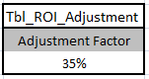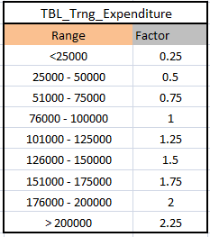

Figure ‑: Adjustment Factor Tables

1. The Year 1 ROI calculation for each of the 6 elements should be performed as follows:
   1. Multiply the amount invested in Year 1 times the gap times the “adjustment factor”
      1. (Year 1 investment amount) x (gap percent) x (adjustment factor)
      2. Example in the embedded spreadsheet for Sales Cycle is shown below:

(D6) *(C7) * (H4)

* 1. The resulting values for the calculations of each of the 6 elements will be part of the calculation for the Year 2 ROI calculations performed in the next step

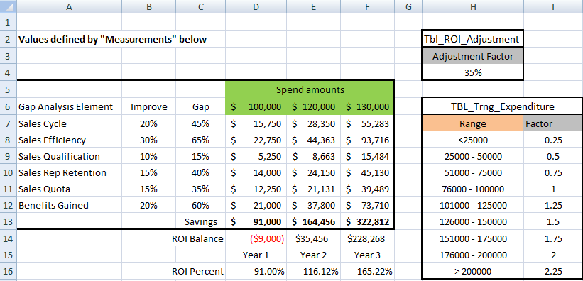

Figure ‑: ROI Calculation Elements

1. The Year 2 ROI calculation for each of the 6 elements should be performed as follows:
   1. Multiply the amount invested in Year 2 times the Step 6 result multiplied by “1 plus the improvement percent”
      1. (Year 2 investment amount) x (Step 6 result) x (1 plus gap percent)
   2. THEN take the Step 7a result and divide it by the Year 1 investment amount
      1. (Step 7a result) / (Year 1 investment amount)
   3. THEN take the Step 7b result and multiply it by the “investment adjustment factor”
      1. (Step 7b result) x (investment adjustment factor)
   4. The example in the embedded spreadsheet for Sales Cycle (Year 2 ROI) is shown below:

(((Year 2 investment) * (Step 6 result) * (1+gap percent))/(Year 1 investment)) *(expense adjustment factor)

((E6 * D7 * (1+B7)) / D6) * I12

* 1. The resulting values for the calculations of each of the 6 elements will be part of the calculation for the Year 3 ROI calculations performed in the next step

1. The Year 3 ROI calculation for each of the 6 elements should be performed as follows:
   1. Multiply the amount invested in Year 3 times the Step 7d result multiplied by “1 plus the improvement percent”
      1. (Year 3 investment amount) x (Step 7d result) x (1 plus gap percent)
   2. THEN take the Step 8a result and divide it by the Year 2 investment amount
      1. (Step 8a result) / (Year 2 investment amount)
   3. THEN take the Step 8b result and multiply it by the “investment adjustment factor”
      1. (Step 8b result) x (investment adjustment factor)
   4. The example in the embedded spreadsheet for Sales Cycle (Year 3 ROI) is shown below:

(((Year 3 investment) * (Step 7d result) * (1+gap percent))/(Year 2 investment)) *(expense adjustment factor)

((F6 * E7 * (1+B7)) / E6) * I13

* 1. The resulting values for the calculations of each of the 6 elements will be part of the calculation for the OVERALL ROI calculations performed in the next step

1. Year 1 ROI Percent
   1. Sum the Step 6 results for each of the 6 elements
   2. Divide the Step 9a result by the Year 1 investment amount and represent as a percentage
   3. The example in the embedded spreadsheet for Year 1 ROI is in Column D, Row 16
   4. This is the value that should be shown in the ROI graph for Year 1
2. Year 2 ROI Percent
   1. Sum the Step 7d results for each of the 6 elements
   2. Divide the Step 10a result by the Year 2 investment amount and represent as a percentage
   3. The example in the embedded spreadsheet for Year 2 ROI is in Column E, Row 16
   4. This is the value that should be shown in the ROI graph for Year 2
3. Year 3 ROI Percent
   1. Sum the Step 8d results for each of the 6 elements
   2. Divide the Step 11a result by the Year 3 investment amount and represent as a percentage
   3. The example in the embedded spreadsheet for Year 3 ROI is in Column F, Row 16
   4. This is the value that should be shown in the ROI graph for Year 3